

Asset Practice Answers: Science

**1. Kamran tried to grow two similar plants, one inside a dark room and the other in the hot Sun, as shown in the figure. He gave the same amount of water to these plants daily. What was he trying to check?**

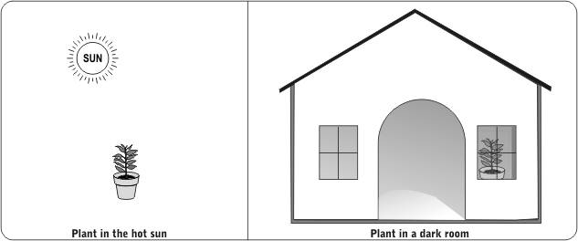

**A.** Do plants need water to grow?

**B. Do plants need light to grow?**

**C.** Do plants need soil to grow?

**D.** Do plants need air to grow?

**2. Raman is blindfolded and he has to identify an object just by hitting it with a metal spoon. He identifies one of them by its ringing sound. Which one is it?**

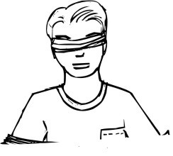

**A.** A brick

**B. A steel plate**

**C.** A book

**D.** A wooden block

**3.** 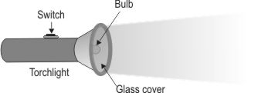

**Akila's torchlight did not light up when she switched it ON. One of the things she should check is .**

**A.** if the glass cover on the torch is in place

**B.** if the torch is made of plastic

**C.** the date on which the torch was bought

**D. if the batteries are fitted in the torch**

**4. Anu takes equal amounts of rice in two vessels and pours the same amount of water in each of them.**

**She then puts them both on the stove for the rice to cook. She wants to check whether rice cooks**

**faster in salt water or in plain water. What else should she do to check this before turning the stove on?**

**A.** Mix salt in both the vessels.

**B. Mix salt in only one of the vessels.**

**C.** Add more water to both the vessels.

**D.** Add more water to only one of the vessels.

**5. Shashank wants to play cricket in the playground. He tries to push the stumps into the ground, but the ground is very hard and the stumps do not go in.**

**What can he try to do to make the stumps go in easily?**

**A.** Rub the stumps with sand to make them rough.

**B.** Apply oil on the stumps to make the surface smooth.

**C.** Blow air on that part of the ground to make the soil loose.

**D. Pour a little water on that part of the ground to make the soil soft.**

**6. Meera looked through the glass window of her house in the afternoon. She could see everything through it. She thought it was because light passes through it easily. Which other object would do the same?**

**A.** A mirror

**B.** A polished plate

**C.** A wooden sheet

**D. A pair of spectacles**

**7. Prem finds that his friend's heart is beating very fast. What could his friend have been doing just before?**

**A. Running up the stairs** **B.** Reading a story book **C.** Eating an ice cream

**D.** Watering his plants

**8. On a hot summer day, Radha keeps the same amount of water in the four containers in the kitchen.**

**After a few hours, water in which container will be coldest?**

**A.** A plastic bottle **B.** A steel vessel

**C. A mud pot**

**D.** A glass bottle

**9. The cover of a gutter in a crowded street was removed and the gutter was left open. What can one do to make sure that nobody falls in?**

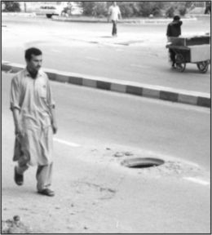

**A. Place some big stones around it.**

**B.** Cover it with big leaves and newspapers.

**C.** Tell a passerby about it and leave it as it is.

**D.** Announce this news over the radio.

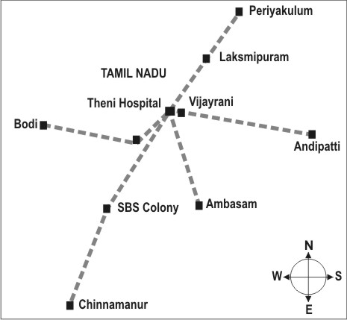**10.**

**Which of these places is located to the North of Theni Hospital?**

**A.** Andipatti

**B.** Ambasam

**C.** Chinnamanur

**D. Laksmipuram**

**11. Look carefully at the map given below.**

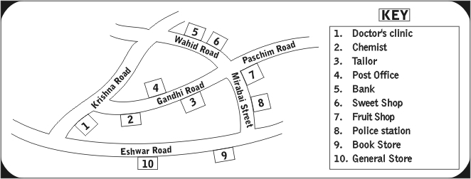

**Which two of these are nearest to each other?**

**A. Bank and Sweet shop**

**B.** Post office and General store

**C.** Fruits shop and Police station

**D.** Doctor's clinic and Chemist

**12. Tina went up to the terrace and noted down all the things she saw in the sky. She saw the Moon, the clouds, some birds, the Sun and an aeroplane. She is looking at the .**

**A.** night sky, because we can see the Moon only in the night

**B.** night sky, because birds and aeroplanes fly only in the night

**C.** day sky, because we see clouds only during the day, and not at night

**D. day sky, because sometimes we see the Sun and the Moon, during the day**



**Science**

1. B: When you want to check whether something is needed for plants to grow, you need to compare two things. For example, if you want to see if plants need water to grow, you should try and grow one plant with water and one plant without water. In the question, both plants are given water, so we cannot find that out. Only one plant is given light, while the other one is not. So, this means that Kamran was trying to see if plants need light to grow. So, option B is the correct answer.
2. B: Try hitting a brick, a steel plate, a book and a wooden block with a metal spoon. Which of them will give the best ringing sound? Only the steel plate will. So, option B is the correct answer. A wooden block will usually not give out a ringing sound.
3. D: The most important things for a torch to work are the batteries, the wires in the torch, the switch and the bulb. If these things are working properly, the torch will definitely light up. The glass cover, material of which the torch is made and the date on which the torch is bought do not matter. So, option D is the only correct answer.
4. B: If you want to check whether rice cooks faster in salt water or in plain water, you need to cook some rice in salt water and some rice in plain water. Then you can check which one cooks faster. This way, you can compare the two. If we mix salt in both vessels or add more water to both vessels, we will not be able to compare. Only option B is the correct answer.
5. D: Try doing this! If the ground is very hard, you can make it slightly softer by pouring a little water on it. Applying oil on the stumps will not help push the stumps in. So, option B is not the correct answer. Only option A is the correct answer.
6. D: Look through the glass window in your house. You can see through it, right? Now pick up a hand-mirror and try to look through it. Can you see what is behind the mirror by looking through the front of the mirror? You will not be able to because we cannot see through the mirror. Light cannot pass through the mirror. So, option A is incorrect. A pair of spectacles have to let you see through them, otherwise how would you see things while wearing spectacles? Option D is the only correct answer.
7. A: Try listening to your friend's heartbeats as they are doing different things. You will find that the heart beats the fastest when you are doing some physical exercise. Reading a story book can make your heart beat faster (especially if it is a scary story!), but your heart will not beat as fast as when you are running or doing some exercise. So, option A is the correct answer.
8. C: Try doing this! Put some water in a plastic bottle, a steel vessel, a mud pot and a glass bottle. Leave it on a table in a room, with no fan or AC. Check the water after 3 or 4 hours. You will find that the mud pot will have the coolest water.

Mud pots were often used in olden days to keep water cool, when there were no refrigerators. So, option C is correct.

1. A: The gutter is open. To make sure that nobody falls inside it, it should be covered or there should be something that can alert people that there is an open gutter. Announcing on radio might take time and not everyone would be listening to a radio. So that will not help. What will help is to place big stones around it so that people would see those stones and come to know that there is some danger there.
2. D: As we can see from the direction symbol, north of Theni Hospital would be higher up in the map. Of the given four places in the options, Laksmipuram is such a place, higher up in the map than Theni Hospital. Andipatti is to the right of Theni Hospital and slightly lower. So it cannot be the answer.
3. A: Have you looked at the map carefully? Which two places are nearest to each other? You will find that places 5 and 6 are next to each other and they are nearest to each other. They are the Bank and the Sweet shop. The Doctor's clinic and the Chemist are also next to each other. But they are not as near to each other as the Bank and the Sweet shop.
4. D: Check what all Tina saw the in the sky. One of the things she saw was the Sun. The Sun cannot be seen at night. So it cannot be the night sky. The Moon can be seen sometimes during the day and so it must be the day sky.